THE UNIVERSITY of THE WEST OF ENGLAND

**FACULTY OF HEALTH AND APPLIED SCIENCES**

# **IONISING RADIATIONS REGULATIONS 2017**

## LOCAL RULES

Radiation Protection Supervisor: **Fiona Chamberlain**

**Tel:** 0117 3288825

**Email: Fiona.Chamberlain@uwe.ac.uk**

Radiation Protection Advisor: **Tony Butterworth**

**Tel:** 01179288323 / 07747600386

**Email: A.R.Butterworth@bristol.ac.uk**

**Classification of Areas**

X-ray units are sited in the Practical X-ray Room (1F01). The controlled Area is marked on the enclosed plan (Appendix A).

Controlled Areas for the use of mobile radiographic units extend 1.5m in all directions from the patient and 1m from the x-ray tube. The member or radiography school staff will control the entry of any person to the Controlled Area. All mobile units will only be used in 1F01

All members of staff, students and visitors enter Controlled Areas under the written arrangements given in these local rules. These written arrangements ensure that all doses received by staff and students will be less than 3/10 of the dose limits listed in IRR2017.

There are separate written arrangements for domestic and maintenance staff and other visitors who are not employed by the University such as visiting staff and engineers (Appendix B).

The x-ray room (1F01), excluding the control area is a Controlled area at all times

**General and Local Rules**

1. Every member of staff or student who routinely works in Controlled Areas must read these local rules and the room specific local rules displayed in each room. They must sign to say that they have read and understand them.
2. Any member of staff or student who may be pregnant must inform their tutor or the Radiation Protection Supervisor (RPS) in writing.
3. An investigation must be carried out by the RPS when the effective dose to a member of staff or student exceeds 0.5 mSv in any 3 month wear period.
4. Only suitably trained authorised staff* or students under direct supervision may operate the x-ray units. *(qualified radiographers, medical physics staff and maintenance engineers.)
5. During positioning the generator must always be disabled when practicable, using the interlock key. (All keys are stored in locked key cupboard only accessible by the personnel listed in point 4)
6. X-ray room doors must be kept closed at all times
7. Everyone must stand behind the protective screens during radiographic exposures where practicable, under the instruction of the member of staff taking the session.  
   Anyone unaccustomed to the department must be told in advance where to stand.
8. Radiation monitors, if provided, must be worn at all times when on duty. When a lead apron is worn the monitor must be worn in the usual position underneath it.
9. All radiation personal protective devices must be immediately available and maintained in good condition. Lead protective aprons will be checked at yearly intervals by means of imaging the devices using the II, and records kept by the RPS.
10. When the room is not in use the x-ray generator must be isolated from the mains. The room must be locked at all times (swipe card access only)
11. When an exposure is about to be made, all persons in the x-ray room will leave the controlled area and stand behind the protective screen **unless** they are wearing a lead-rubber apron and have been expressly instructed by a member of staff that it is safe to remain where they are.
12. The x-ray beam must not be directed towards the control panel
13. When a mobile x-ray unit or image intensifier is in use all persons in the room must remain behind the protective screen **unless** they are wearing a lead-rubber apron and have been expressly instructed by a member of staff that it is safe to remain where they are.

### Contingency Plans/ Fault Reporting

1. There is a possibility that an x-ray unit may fail to terminate an exposure. The operator must make themselves aware of the location and operation of any emergency stop devices before attempting to use any of the 3 imaging devices, (the static overcouch X-ray unit, AMX 4 and Siemens C-arm mobile units). This must cover any mechanical, electrical and ionising radiation emergency stop devices.
2. Any accidental exposure to staff or students that may be much greater than intended, due to operator error or to a malfunction of an X-ray unit, must be reported to the Radiation Protection Supervisor or in the absence of the RPS, the Radiation Protection Adviser.
3. Any equipment malfunction must be reported without delay (via email to RPS) and an entry made in the room fault book. If the equipment is not safe to be used, a sign (available in cupboard) must be displayed on the door or the control panel. A record must be kept of the measures made to rectify the fault and must be reported to the Radiation Protection Supervisor or in the absence of the RPS, the Radiation Protection Adviser; and not used again until the RPA has authorised this.
4. Handover to engineers will be carried out by the Radiation Protection Supervisor or a designated individual. Not in use signs will be placed on the entrance to the controlled area and note will be made on the handover sheet. On completion of any works the room will be handed back with a description of the works completed and any notes. This will be signed by the engineer / physicist and the University representative.

**APPENDIX A**

PLANS SHOWING CONTROLLED AREAS WITHIN THE X‑RAY DEPARTMENTS.

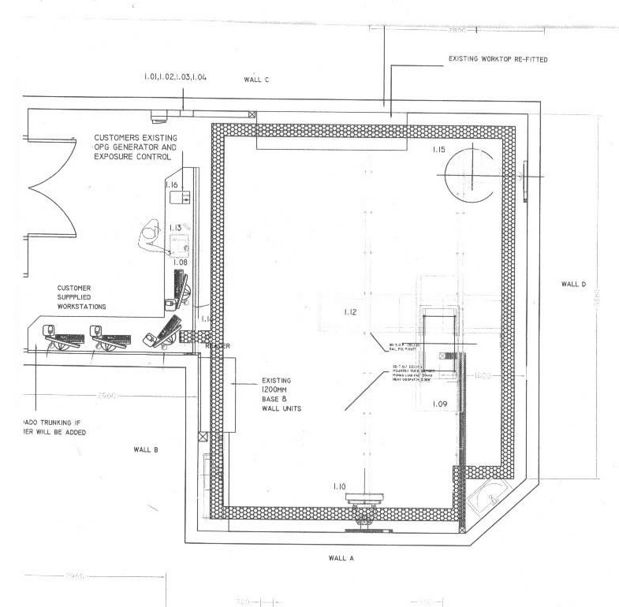

APPENDIX B

**WRITTEN ARRANGEMENTS FOR VISITORS & STAFF WHO DO NOT NORMALLY WORK IN CONTROLLED AREAS**

**THE UNIVERSITY OF THE WEST OF ENGLAND**

**FACULTY OF HEALTH AND SOCIAL CARE**

**WRITTEN ARRANGEMENTS**

**Visitors**

All staff other than radiography school staff and visitors

1) Visitors may only enter the x-ray room (1F01) with the permission of a member of Radiography university staff

2) Visitors, other than service engineers or medical physics staff, must be supervised by a member of Radiography university staff. They must not enter the Controlled Area when an exposure is being made

3) All visitors must leave the Controlled Area or stand behind a protective screen when x-rays are being generated except when their presence is essential to the procedure or for observation of that procedure for teaching purposes. Protective clothing and/or screens appropriate to the procedure must be used, as recommended by the RPA. When a visitor is judged to be at greater risk of exposure than any member of the radiographic staff the visitor must wear a personal dose monitor, issued by the RPS.

4) In the case of mobile x-ray units, the radiographer must be responsible for clearing the Controlled Area where practicable and ensuring that only necessary staff or visitors remain in the area.

**APPENDIX C**

**List of Imaging Equipment in 1F01**

X-O Graph Bucky Star overcouch tube (Siemens), with table and vertical bucky

including CANON CDXI 11, 22, 31, INDICO 100, 3DTOP, ET8520 TABLE

GE AMX 4 plus – mobile unit S/No 195490011-122

Siemens Siremobil Compact mobile C-arm S/No 006-TRI1101

Fuji CR system and plates 18x24, 24x30 and 43x35